MATH 4371 MIDTERM (Spring 2008)

Name: SID:

The following is an assortment of True/False (the appropriate one to be circled) questions, fill in the blank questions, and computational questions. Use either machine you wish, or neither machine as you see fit. Read each question very carefully, and for those that require written response, be as neat and to the point as possible.

1. Assume m, n, and r are positive integers.
a. What does it mean to say that "r is the greatest common divisor of m and n" ?

b. What does it mean to say that "r = m mod n" ?

c. Compute the following integers:
gcd(8,12) =
gcd(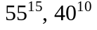) =
9 mod 5 =
lcm(508,450) =
10 ! mod 5 =
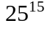 mod 2 =
d. Explain why and odd integer times and odd integer must be an odd integer.

2. State the FUNDAMENTAL THEOREM OF ARITHMETIC.
Demonstrate this theorem for the integer 50!.

50! =

3. Convert the following numbers in Sci-Notation to the equivalent actual number.
1.9123 E5 =
1.9123 E-5 =
4. What are the integer fractions represented by the following decimal numbers.
2.2333 =
2.233 =
TRUE / FALSE
5. Not all real numbers have an equivalent integer fraction representation.

6. There are rational numbers which the calculator can not convert to integer fraction form.
TRUE / FALSE

7. What does the BINOMIAL THEOREM tell us?

Use MAPLE to demonstrate the BINOMIAL THEOREM.

What is the coefficient of 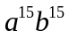 in the expansion of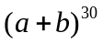?

TRUE / FALSE
8. MAPLE can find the exact roots of all cubic polynomials.

9. The calculator can find the exact roots of all quadratic polynomials.
TRUE / FALSE

10. The calculator can factor any polynomial into a product of powers of first
degree polynomials.
TRUE / FALSE

11. Find all the roots of each of the following polynomials:
a. 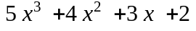

b. 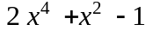

What do the roots of a polynomial have to do with its graph?

12. Factor each of the following polynomials into a product of 1st order terms:
=

=

What do the factors of a polynomial have to do with its roots?

13. Insert the graph of the following function: 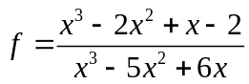 .

What are the vertical asymptotes of f?

What is the horizontal asymptote of f ?

14. Find the x-intercepts of the graphs of each of the following functions:

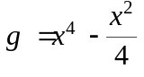

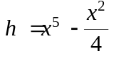

15. For any polynomial p(x) you can always find a number M so that the graph of p(x)+M never crosses the x-axis.
TRUE / FALSE

16. For any even degree polynomial p(x) you can always find a number M so that the polynomial p(x)+M has no real roots.
TRUE / FALSE

17. For any odd degree polynomial p(x) you can always find a number M so that the polynomial p(x)+M has exactly one real root.
TRUE / FALSE

18. Some graphs of functions contain a vertical line.
TRUE / FALSE

19. Suppose the following is the graph of some unknown function h(x).

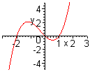

What are the solutions to the equation h(x)=0?

How does the graph of h(x)+1 compare with the graph of h(x)?
How does the graph of h(x+1) compare with the graph of h(x)?

20. Insert a picture which shows the effect of changing the parameter k on the graphs of y= x³-4x+k.

21. (Bonus) Insert a picture of the graph of a function y=g(x) satisfying the following properties: the zeros of g(x) are at x=-1 and x=0, g has a vertical asymptote at x=2, and g has horizontal asymptote y=1.

